Guided Capstone Project Report
Summary:
Big Mountain Resort (BMR) has recently installed an 12th Chairlift to help increase the distribution of visitors across their mountain at a cost of $1,540,000. The business profit margin is 9.2% and the investors in Big Mountain Resort would like to keep it there. This means that BMR needs to generate an additional $1.7M of revenue in order to cover these costs. Currently, there are 350,000 people skiing at BMR each year, and this would mean that if the customer stayed the same, we would need to generate an additional $4.85 per customer per year in order to generate this revenue.
Analysis:
Coefficient
summit_elev | 1.757163e+00
vertical_drop | 1.077296e+00
total_chairs | 2.825089e+12
Montana | 9.069844e+12
In order to figure out the right price point for BMR with it’s offerings, my team compared data on Vertical Drop, location, total charis, runs, Terrain Parks, Longest Runs, Skiable Terrain, Snow Making, Days Open, Average Snowfall, Projected Days Open, and Nightskiiing, and we compared these metrics to the Adult Weekend prices at 330 different resorts in the US in order to determine which features were most closely correlated with price. By looking at all of these features and building a multiple regression model, we were able to figure out which of these features were most closely correlated with the Adult Weekend price across the country. The results of looking at the correlation coefficients vs price rendered the results below:
As you can see in the table to the left, location is the largest driver of price, followed by the total amount of chairs, then by summit elevation and vertical drop.
State is by far the largest indicator of price. Across Montana, the average price is $53 per day and the correlation between price and the state of Montanta is 9.069844e+12. (see figures below). You can see the prices for Montana Resorts in the figure below in the “1” region.

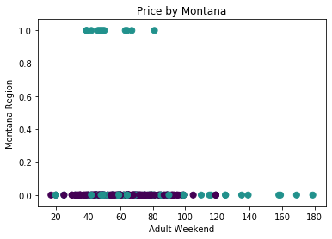
For reference, BMR charges $81 per day right now. Additional analysis shows that the correlation between price and total chairs is strong, and so is the correlation between price and vertical drop (see charts below).

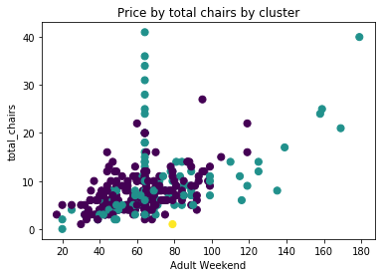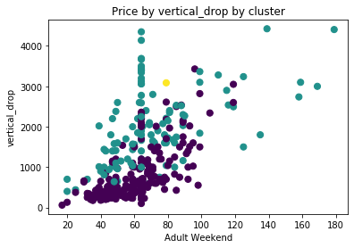
We built a multiple regression model to see how well all of the variables in our dataset explained Adult Weekend Prices, and the R-squared was .94, which indicates that the model is strongly indicative of pricing.

Conclusion:
According to the regression model, we should reduce our price to $64 in order to make up this lost revenue. When running the regression model against the data points of BMR, we see that the current price is high in comparison to all other Montana resorts. Also looking at total chairs and vertical drop, it looks like the metrics of BMR are more competitive with other resorts in the mid 60s price range. A price drop will bring in substantially more customers, and overall this revenue will pay for our new lift.

